

**__________________________________________________________________________________**

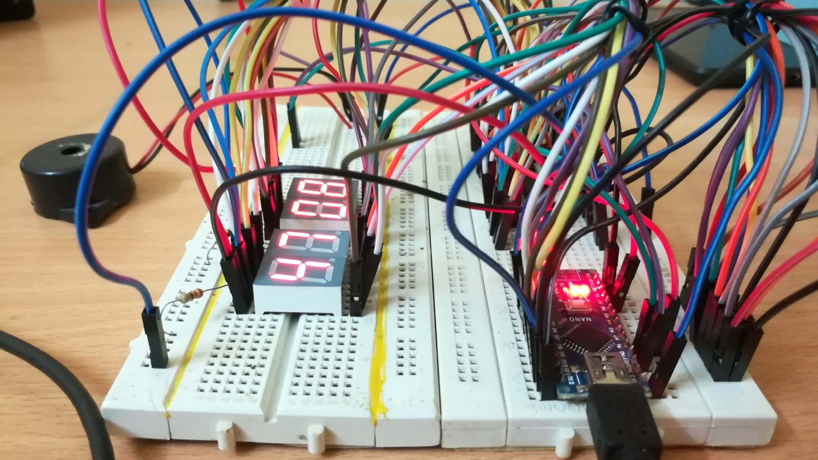

**Count up-till 100 Using Arduino and LCD screen**

Made by : Madhur Nagrath

Roll no. : 19CSU169

Submitted To: Dr. Amanpreet Kaur

__________________________________________________________________________________

Introduction

Arduino is an open-source electronics platform based on easy-to-use hardware and software. [Arduino boards](https://www.arduino.cc/en/Main/Products) are able to read inputs - light on a sensor, a finger on a button, or a Twitter message - and turn it into an output - activating a motor, turning on an LED, publishing something online. You can tell your board what to do by sending a set of instructions to the microcontroller on the board. To do so you use the [Arduino programming language](https://www.arduino.cc/en/Reference/HomePage) (based on [Wiring](http://wiring.org.co/)), and [the Arduino Software (IDE)](https://www.arduino.cc/en/Main/Software), based on [Processing](https://processing.org/).

Over the years Arduino has been the brain of thousands of projects, from everyday objects to complex scientific instruments. A worldwide community of makers - students, hobbyists, artists, programmers, and professionals - has gathered around this open-source platform, their contributions have added up to an incredible amount of [accessible knowledge](http://forum.arduino.cc/) that can be of great help to novices and experts alike.

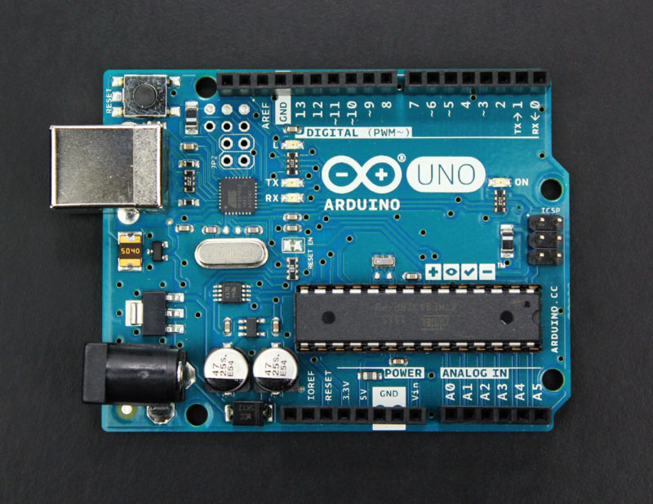



LiquidCrystal Library

|  |
| --- |
| This library allows an Arduino board to control LiquidCrystal displays (LCDs) based on the Hitachi HD44780 (or a compatible) chipset, which is found on most text-based LCDs. The library works with in either 4- or 8-bit mode (i.e. using 4 or 8 data lines in addition to the rs, enable, and, optionally, the rw control lines).  To use this library #include <LiquidCrystal.h> |

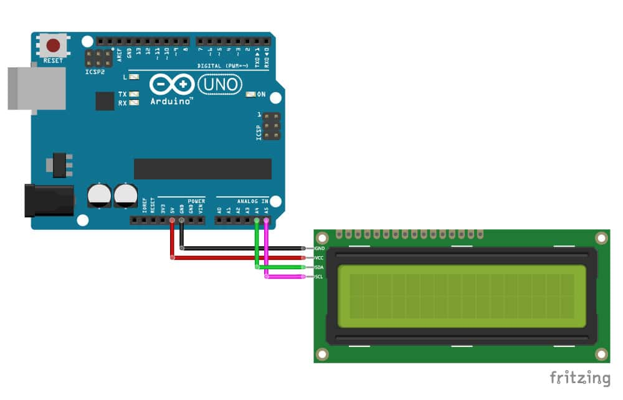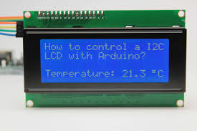

Use of delay() function

#### **Description**

Pauses the program for the amount of time (in miliseconds) specified as parameter. (There are 1000 milliseconds in a second.)

#### **Syntax**

delay(ms)

#### **Parameters**

ms: the number of milliseconds to pause (unsigned long)

#### **Returns**

Nothing

#### Why You Shouldn't Always Use the Arduino Delay Function | Random Nerd Tutorials

## Components required

## Male to male wire

## Male to female wire

## Female to female wire

## 16X2 LCD screen

## 200 ohm resistor

## LED’s

## Arduino

## Push Button

## 

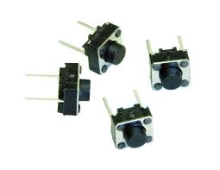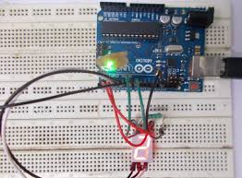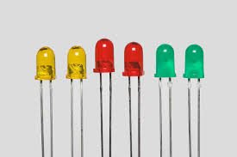

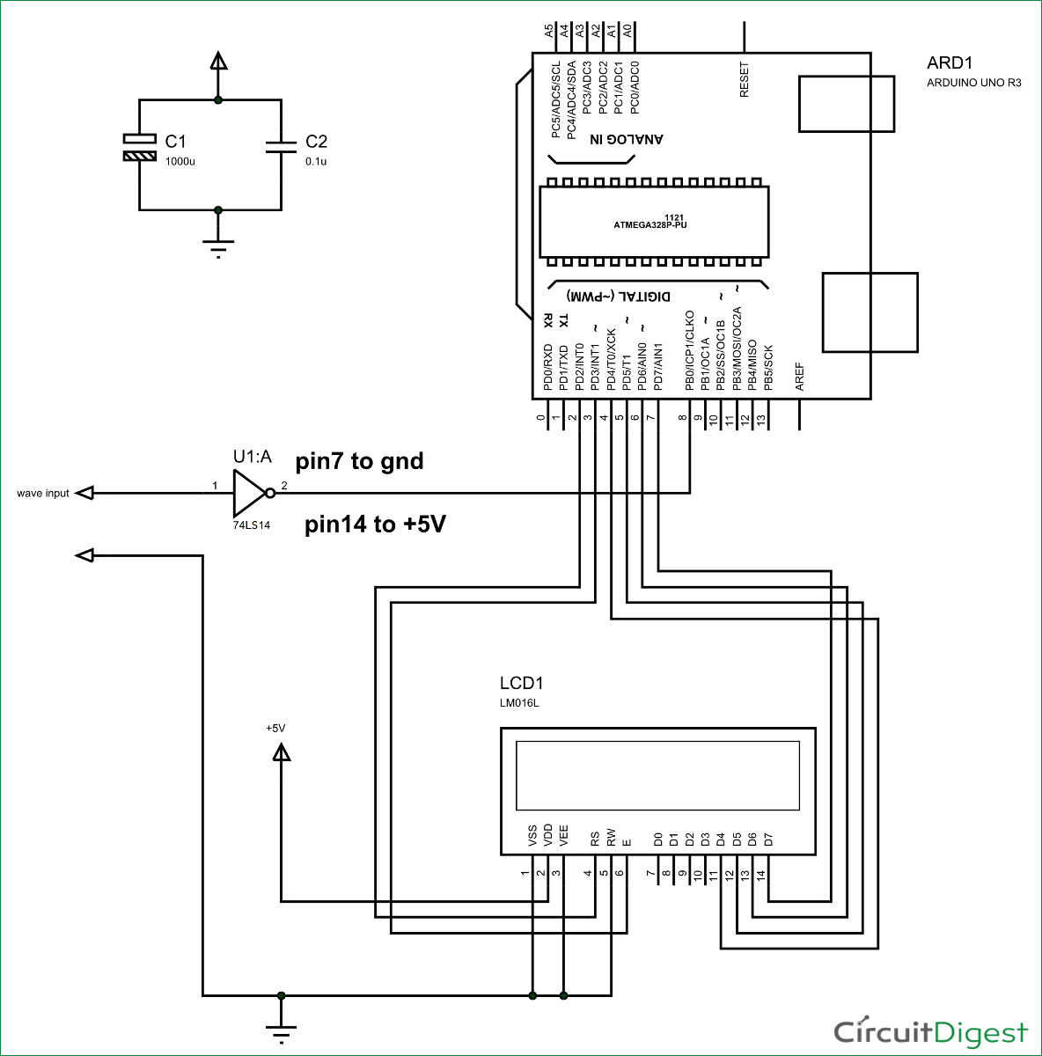Circuit Diagram

Procedure

**Step1 :** build a simple Arduino LCD counter using simple components like LCD.

**Step2 :** Connect an LCD to Arduino board.

**Step3:** Write a program in the Arduino IDE.

**Step4:** Write the code for void loop.

**Step5:** Write a simple if statement to check whether the pushbutton is pressed or not.(Optional step).

**Step6:** Compile and upload the program.

**Step7:** Modify the program to set a counter by adding a while loop(when Ush button is included)

**Step8:** Again compile and upload the program.

Programme

#include <LiquidCrystal.h> // include the library code

LiquidCrystal lcd(12, 11, 5, 4, 3, 2); // initialize the library with the numbers of the interface pins

void setup() {

lcd.begin(16, 2); // set up the LCD's number of columns and rows;

}

for(int i=1;i<101;i++){

lcd.print(i); // Print numbers on the LCD.

delay(750);

}

}

void loop() {

lcd.setCursor(0, 1); // set the cursor to column 0, line 1

lcd.print(millis() / 1000); // print the number of seconds since reset

}

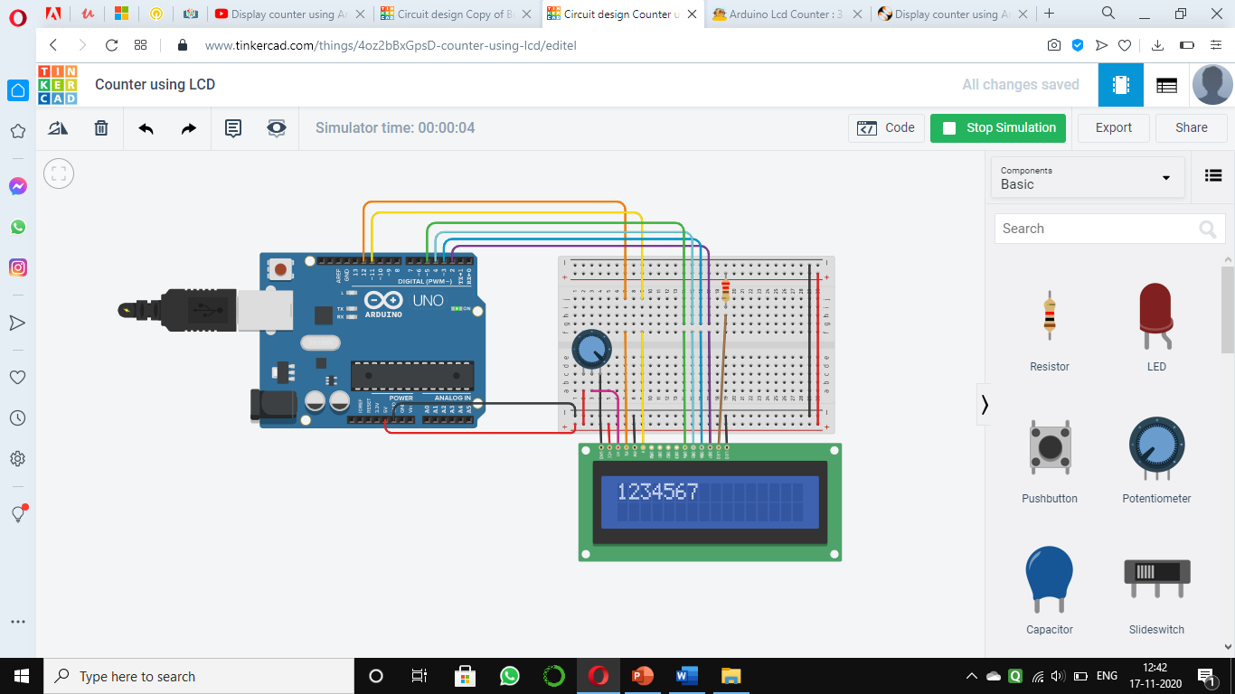Output :

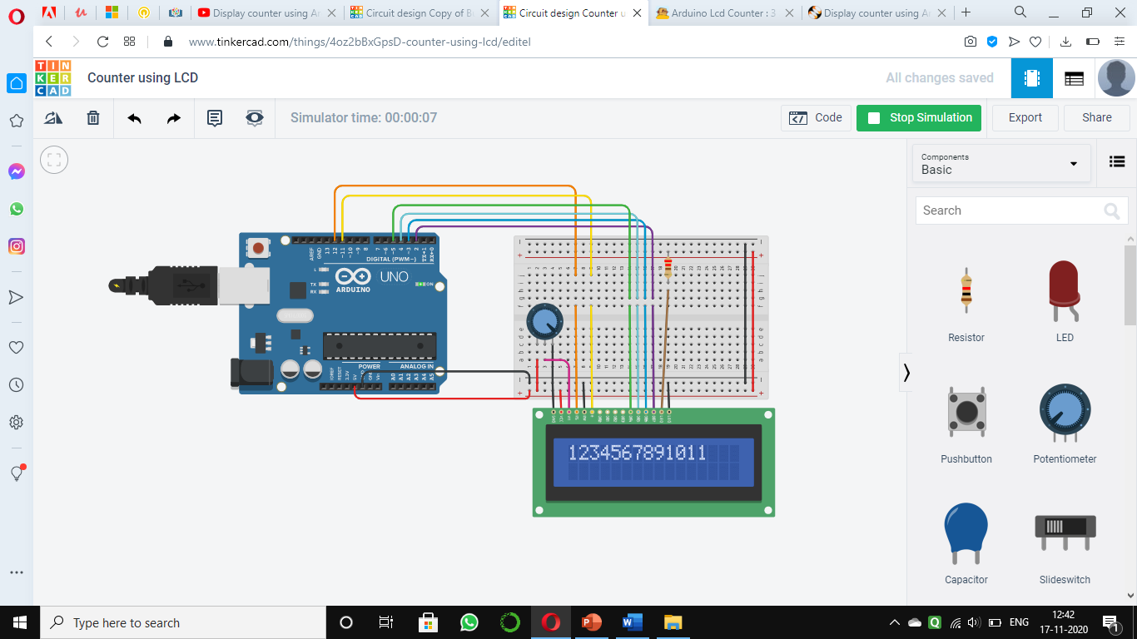

Applications :

1.Used in JO interval time.

2. Time display machines

